Steven Mathias
8/1/2026
CS 499 Capstone
Module Five
Enhancement Two: Narrative
For enhancement three, I continued to work on the Course Planner C++ program that was created for CS 300. This program presents the user with a menu to load data from a course list file, and once loaded, print a list of all courses, print a specific course, or exit the program. The program parses each line of the file loaded and stores the Course ID, name and prerequisites. The previous enhancement updated the unordered_map to a linked list data structure. For enhancement three, the category of databases, I chose to implement a fully functional login method that connects to an SQLite database to authenticate a user to determine if they are an admin or a standard user. If an admin, additional CRUD (Create, Read, Update, Delete) features become assessable.
By adding these enhancements, I demonstrate the ability to perform a common, yet complex, structure for authenticating a user that requires different functionality based on their role. In addition to verifying and authenticating credentials, I also added security methods for preventing SQL injection. The prepared statement ensures that an SQL injection is not passed into the program and read as a command. The SQLite database integration takes the simple program that only loads and displays data from a file, into a much more complex system, reflecting successful software engineering methods and practices.
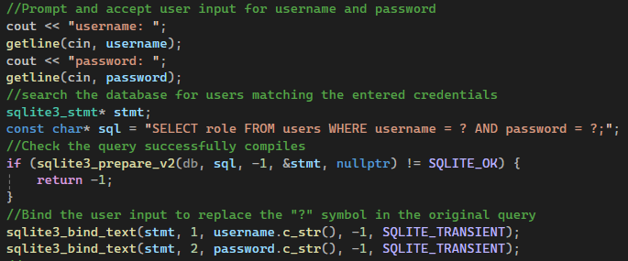
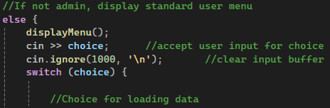
While the database requirement was satisfied with the SQLite database integration along with the login authentication, I wanted to push myself to see if I could complete the additional element of CRUD for an admin user. This ended up being the most difficult aspect the main method required a lot of tweaking and trial and error to get fully functional. I knew that I could keep most of the code the same as before, to follow a user choice with cases for the menu options. However, there were many small details that had to be corrected for the flow between the while loops for admins versus a standard user. I was able to get it semi-functional pretty quickly, but the specific positioning of “cin >> choice”, and return values required a lot of testing, going through the program with each option for both user and admin to ensure each option worked as it should, as well as returned the appropriate menu or response.
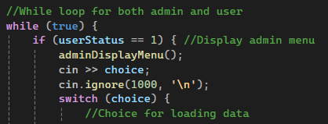

As this enhancement completes the three major components, I believe that I have successfully met the course outcomes, combining software engineering principles for code architecture and programming design, secure coding, data structures and finally database integration. Across my three enhancements, I demonstrate a well-rounded and logical approach to successfully completing programming projects across an array of project types.
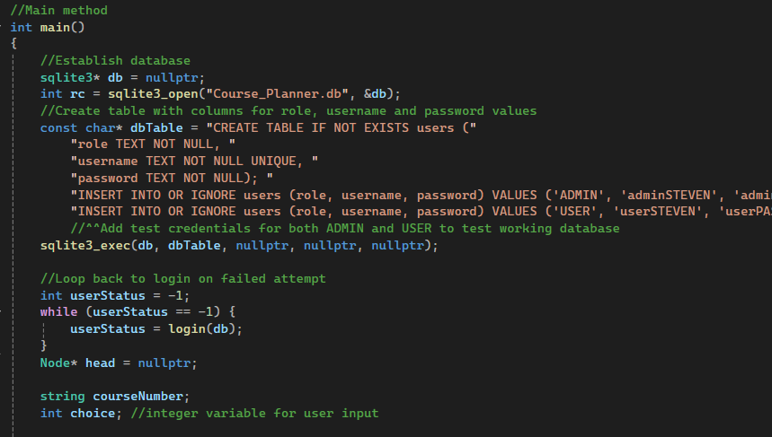
The primary thing that I learned with this enhancement was the implementation of SQLite and CRUD from scratch. In previous assignments, there was at least some level of roadmap or completed code to work from. For this project, the program was fully functional to perform a simple task without the enhancements. The database and CRUD operations were added from scratch to take this program to the next level of complexity. I learned about the importance of planning architecture ahead of time to avoid major changes down the road that waste time and resources. When dealing with as many interworking components as this program became, I had to stop and hand-draw a simple diagram to understand how the separation of roles worked for the user and admin, and how I wanted to place each function in visual studio.

